**Face Mask Detection**

***This project report is submitted to Yeshwantrao Chavan College of Engineering***

***(An Autonomous Institution Affiliated to Rashtrasant Tukdoji Maharaj Nagpur University)***

***In partial fulfilment of the requirement For the award of the degree***

***of***

***Bachelor of Engineering in Electronics & Telecommunication Engineering***

***by***

**Aakib Sayyad**

**Ritik Pusdekar**

**Mohit Zade**

**Tejas Ubale**

**Rohit Samarth**

***Under the guidance of***

**Prof N.A. Pande**



**DEPARTMENT OF Electronics & Telecommunication Engineering**

**Nagar Yuwak Shikshan Sanstha’s**

**YESHWANTRAO CHAVAN COLLEGE OF ENGINEERING,**

**(An autonomous institution affiliated to Rashtrasant Tukdoji Maharaj Nagpur University, Nagpur)**

**NAGPUR – 441 110**

**2021-2022**

**CERTIFICATE OF APPROVAL**

This is to Certify that the project report entitled “**Face Mask Detection**” has been successfully completed by **Aakib Sayyad,** **Ritik Pusdekar, Mohit Zade**, **Tejas Ubale and Rohit Samarth** under the guidance of **Prof. N A Pande** in recognition to the partial fulfilment for the award of the degree of Bachelor of Engineering in Electronics & Telecommunication Engineering, **Yeshwantrao Chavan College of Engineering (An Autonomous Institution Affiliated to Rashtrasant Tukdoji Maharaj Nagpur University)**

**Signature Signature**

Prof. N.A Pande Dr. M. S. Narlawar

**(Guide) (HOD, ET Dept)**

**Declaration**

We hereby declare that

a. The work contained in this project has been done by us under the guidance of my supervisor(s).

b. The work has not been submitted to any other Institute for any degree or diploma.

c. We have followed the guidelines provided by the Institute in preparing the project report.

d. We have conformed to the norms and guidelines given in the Ethical Code of Conduct of the Institute.

e. Whenever we have used materials (data, theoretical analysis, figures, and text) from other sources, we have given due credit to them by citing them in the text of the report and giving their details in the references. Further, we have taken permission from the copyright owners of the sources, whenever necessary

Signature & Name of the Students

1. Ritik Pusdekar

2. Mohit Zade

3. Tejas Ubale

4.Rohit Samarth

5.Aakib Sayyad

**Acknowledgement:**

We sincerely acknowledge with a deep sense of gratitude to our project guide Prof. N.A Pande for the guidance and encouragement she gave us for the preparation of this project. Without her support, the project would have been difficult.

We are highly obliged to Dr. U. P. Waghe (Principal), Dr. M. S. Narlawar, H.O.D (Department of Electronics & Telecommunication Engineering), for their noble, spontaneous, and timely help that carried us throughout our endeavor and finally made a grand success.

We also thank the staff of our electronics department for all the cooperation and friendly treatment given to us during the project. We are also thankful to our colleagues and all those who have extended the necessary help during the course of work.

**CONTENTS**

Page no

Title Page i

Certificate of Approval ii

Declaration iii

Acknowledgement iv

List of figures vi

Abstract vii

Chapter 1: Introduction 1

Chapter 2: Problem Formulation and Objectives 2

Chapter 3: .Literature Review 3

Chapter 4: Construction and Working of Model 5

Chapter 5: Details of Tools used, Process followed 8

Chapter 6: Results 12

Chapter 7: Conclusion and Future scope 16

Chapter 8: Literature cited 17

Chapter 9: Appendix 18

Chapter 10: Relevance of Project 29

**LIST OF FIGURES**

Figure 1. Flowchart of proposed model

Figure 2. Images with mask

Figure 3 Images without mask

Figure 4 MobilenetV2 CNN model

Figure 5 Convolutional layer in CNN model

Figure 6 MaxPool in CNN model

Figure 7 Batch Normalization in CNN model

Figure 8 Dense layer in CNN model

Figure 9 Training Loss and Accuracy

Figure 10 Without Mask (Single Person)

Figure 11 Without Mask (Multiple Person)

Figure 12 With Mask (Single Person)

Figure 13 With Mask (Multiple Person)

Figure 14 One Person with Mask One without Mask

**Abstract:**

The COVID-19 pandemic is causing a worldwide emergency in healthcare. This virus mainly spreads through droplets which emerge from a person infected with corona-virus and poses a risk to others. The risk of transmission is highest in public places. One of the best ways to stay safe from getting infected is wearing a face mask in open territories as indicated by the World Health Organization (WHO). In this project, we propose a method which employs TensorFlow and OpenCV to detect face masks on people. A bounding box drawn over the face of the person describes whether the person is wearing a mask or not. If a person’s face is stored in the database, it detects the name of the person who is not wearing a face mask and an email will be sent to that person warning them that they are not wearing a mask so that they can take precautions.

In the near future, many public service providers will ask the customers to wear masks correctly to avail of their services. Therefore, face mask detection has become a crucial task to help global society. This paper presents a simplified approach to achieve this purpose using some basic Machine Learning packages like TensorFlow, Keras and OpenCV. The proposed method detects the face from the image correctly and then identifies if it has a mask on it or not. As a surveillance task performer, it can also detect a face along with a mask in motion. The method attains accuracy up to 95.77% and 94.58% respectively on two different datasets. We explore optimized values of parameters using the Sequential Convolutional Neural Network model to detect the presence of masks correctly without causing over-fitting.

**Chapter 1: Introduction**

According to the World Health Organization (WHO)’s official Situation Report – 205, coronavirus disease 2019 (COVID-19) has globally infected over 20 million people causing over 0.7million deaths . Individuals with COVID19 have had a wide scope of symptoms reported – going from mellow manifestations to serious illness. Respiratory problems like shortness of breath or difficulty in breathing is one of them. Elder people having lung disease can possess serious complications from COVID-19 illness as they appear to be at higher risk.

To curb certain respiratory viral ailments, including COVID-19, wearing a clinical mask is very necessary. The public should be aware of whether to put on the mask for source control or aversion of COVID-19. Potential points of interest of the utilization of masks lie in reducing vulnerability of risk from a noxious individual during the “pre-symptomatic” period and stigmatization of discrete persons putting on masks to restrain the spread of virus. WHO stresses on prioritizing medical masks and respirators for health care assistants. Therefore, face mask detection has become a crucial task in present global society.

**Chapter 2: Problem Definition:**

COVID-19 pandemic has rapidly affected our dayto-day life disrupting world trade and movements. Wearing a protective face mask has become a new normal. In the near future, many public service providers will ask the customers to wear masks correctly to avail of their services.

Therefore, face mask detection has become a crucial task to help global society.

Our Goal is to propose a model through which we can determine if a person is wearing the mask or not. We aim to increase the accuracy of the model and provide assistance.

**Chapter 3: Literature Review**

**[1] Covid-19 Face Mask Detection Using TensorFlow, Keras and OpenCV**

Year of published: 2020

Authors: Arjya Das,Mohammad Wasif Ansari,Rohini Basak

This paper presents a simplified approach to achieve this purpose using Machine Learning packages like TensorFlow, Keras, OpenCV and Scikit-Learn. The proposed method detects the face from the image correctly and then identifies if it has a mask on it or not. As a surveillance task performer, it can also detect a face along with a mask in motion.

**[2]** **An Approach to Face Detection and Recognition**

Year of published: 2016

Authors: Divya Meena,Ravi Sharan

Face detection has attracted immense attention because it has many applications in computer vision communication and automatic control system. Research into face detection, expression recognition, face tracking, pose estimation is required. By giving a single image, the challenge is to detect the face from that image. Face detection is a challenging task because faces are not rigid and it changes in size, shape, color etc. In this paper, viola Jones algorithm is used to detect face and principal component analysis for face recognition

**[3] Face Mask Detection Using OpenCV**

Year of published: 2021

Authors: Harish Adusumalli ,D Kalyani

The COVID-19 pandemic is causing a worldwide emergency in healthcare. This virus mainly spreads through droplets which emerge from a person infected with coronavirus and poses a risk to others. The risk of transmission is highest in public places. One of the best ways to stay safe from getting infected is wearing a face mask in open territories as indicated by the World HealthOrganization (WHO). In this project, we propose a method which employs TensorFlow and OpenCV to detect face masks on people. A bounding box drawn over the face of the person describes whether the person is wearing a mask or not.

**[4]** **Advice on the use of masks in the context of COVID-19**

Year of published: 2020

Authors: WHO

This document provides advice on the use of masks in communities, during home care, and in health care settings in areas that have reported cases of COVID-19. It is intended for individuals in the community, public health and infection prevention and control (IPC) professionals, health care managers, health care workers (HCWs), and community health workers.

**[5]** **Face Mask Detection using Transfer Learning of InceptionV3**

Year of published: 2020

Authors: G. Jignesh Chowdary, Narinder Singh Punn ,Sanjay Kumar Sonbhadra and Sonali Agarwal

In this paper, a transfer learning model is proposed to automate the process of identifying the people who are not wearing mask. The proposed model is built by fine-tuning the pre-trained state-of-the-art deep learning model, InceptionV3. The proposed model is trained and tested on the Simulated Masked Face Dataset (SMFD). Image augmentation technique is adopted to address the limited availability of data for better training and testing of the model. The model outperformed the other recently proposed approaches by achieving an accuracy of 99.9% during training and 100% during testing.

**Chapter 4 : Construction and Working of Model:**

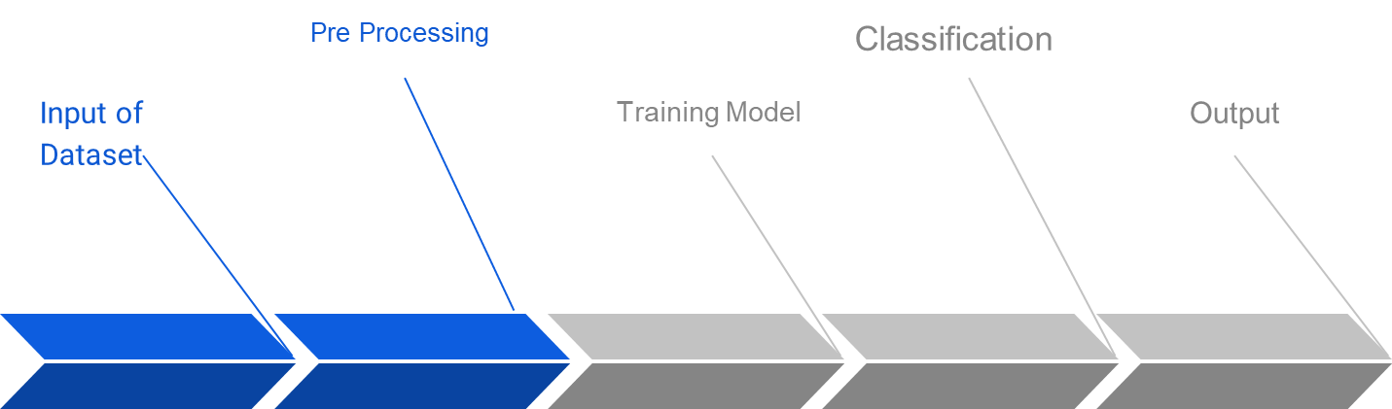

**Figure 1. Flowchart of proposed model**

**4.1 Dataset:**

The dataset was collected from Kaggle Repository and it contains 3833 images, out of the total images 1918 images are without mask images and 1915 are with mask images.

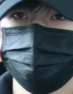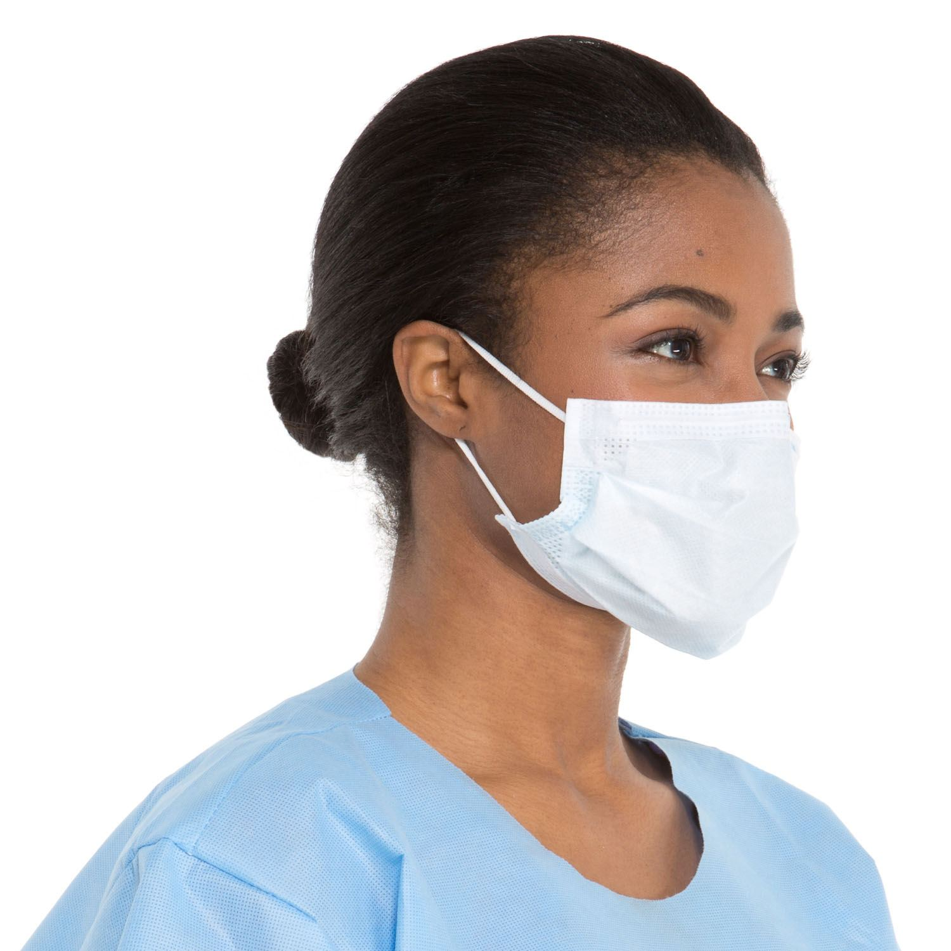

**Figure 2. Images with Mask**

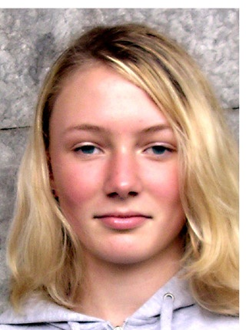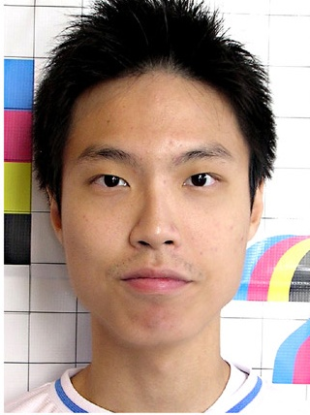

**Figure 3 Images Without Mask**

**4.2. Pre processing:**

In the proposed model read the images in the dataset using OpenCV. This list of images in the dataset directory, then initialize the list of data(i.e. images) and class images. After the images are successfully loaded they are converted into an array. This data is then appended in data and labels.

When the data is loaded and converted into an array, One hot encoding is performed for this label binarizer is used. Label Binarizer is a function to perform the transform operation of LabelBinarizer with fixed classes. It helps to convert multi-class labels to binary labels.

**4.3 Training model and Classification:**

Now the data is successfully loaded in the model, this data is now split into train and test using sklearn. The train split is passed through the Image Data Generator.ImageDataGenerator class provides a quick and easy way to augment your images. It provides a host of different augmentation techniques like standardization, rotation, shifts, flips, brightness change, and many more.

Inorder to train the model MobilenetV2 is used. This model is a convolutional neural network architecture that seeks to perform well on mobile devices. It is based on an inverted residual structure where the residual connections are between the bottleneck layers.The intermediate expansion layer uses lightweight depthwise convolutions to filter features as a source of non-linearity. As a whole, the architecture of MobileNetV2 contains the initial fully convolution layer with 32 filters, followed by 19 residual bottleneck layers.

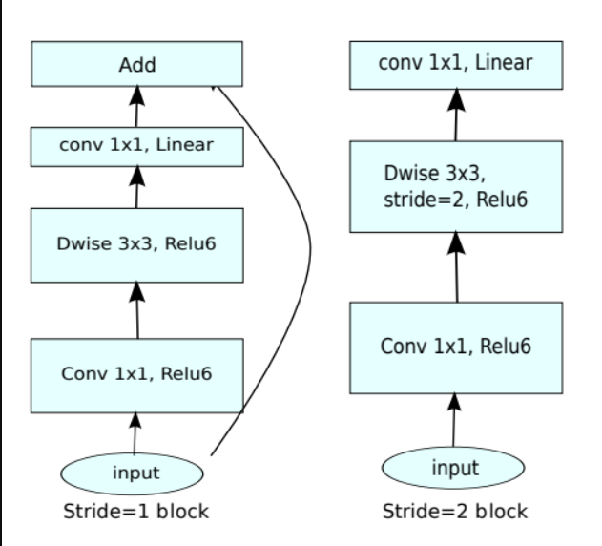

**Figure 4. MobilenetV2 CNN model**

**4.4 Prediction:**

Inorder to predict the are using imutil, it will help to start the video stream through which we will be able to detect the mask. If the person is wearing a mask in the video it will be shown in green box and if the person is not wearing a mask it will show in red box.

**Chapter 5: Details of**

**5.1 Tools used**

**5.1.3 TensorFlow:**

TensorFlow, an interface for expressing machine learning algorithms, is utilized for implementing ML systems into fabrication over a bunch of areas of computer science, including sentiment analysis, voice recognition, geographic information extraction, computer vision, text summarization, information retrieval, computational drug discovery and flaw detection to pursue research . In the proposed model, the whole Sequential CNN architecture (consists of several layers) uses TensorFlow at backend. It is also used to reshape the data (image) in the data processing.

**5.1.2: Keras:**

Keras gives fundamental reflections and building units for creation and transportation of ML arrangements with high iteration velocity. It takes full advantage of the scalability and cross-platform capabilities of TensorFlow. The core data structures of Keras are layers and models. All the layers used in the CNN model are implemented using Keras. Along with the conversion of the class vector to the binary class matrix in data processing, it helps to compile the overall model.

**5.1.3 OpenCV:**

OpenCV (Open Source Computer Vision Library), an open source computer vision and ML software library, is utilized to differentiate and recognize faces, recognize objects, group movements in recordings, trace progressive modules, follow eye gesture, track camera actions, expel red eyes from pictures taken utilizing flash, find comparative pictures from an image database, perceive landscape and set up markers to overlay it with increased reality and so forth [20]. The proposed method makes use of these features of OpenCV in resizing and color conversion of data images

**5.1.4 CNN model:**

In neural networks, Convolutional neural networks (ConvNets or CNNs) is one of the main categories to do image recognition, images classification. Object detections, recognition faces etc., are some of the areas where CNNs are widely used.

CNN image classifications take an input image, process it and classify it under certain categories (as in this paper in normal and abnormal) Computers see an input image as an array of pixels and it depends on the image resolution. Based on the image resolution, it will see h x w x d( h = Height, w = Width, d = Dimension ). Eg., An image of a 6 x 6 x 3 array of matrix of RGB (3 refers to RGB values) and an image of 4 x 4 x 1 array of matrix of grayscale image.

Technically, deep learning CNN models to train and test, each input image will pass it through a series of convolution layers with filters (Kernels), Pooling, fully connected layers (FC) and apply Softmax function to classify an object with probabilistic values between 0 and 1. The below figure is a complete flow of CNN to process an input image and classifies the objects based on values.

CNN model works in following steps:

* Provide input image into convolution layer
* parameters, apply filters with strides, padding if required. Perform convolution on the image and apply ReLU activation to the matrix.
* Perform pooling to reduce dimensionality size
* Add as many convolutional layers until satisfied
* Flatten the output and feed into a fully connected layer (FC Layer)
* Output the class using an activation function (Logistic Regression with cost functions) and classifies images.

**5.2 Processes Followed:**

**5.2.1 Convolutional layer:**

Convolution is the first layer to extract features from an input image. Convolution preserves the relationship between pixels by learning image features using small squares of input data. It is a mathematical operation that takes two inputs such as image matrix and a filter or kernel.

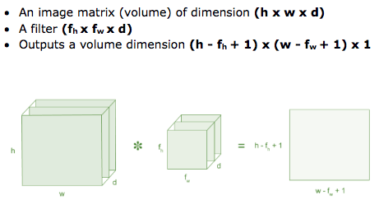

**Figure 5 Convolutional layer in CNN model**

**5.2.2 MaxPool layer:**

The pooling operation involves sliding a two-dimensional filter over each channel of feature map and summarising the features lying within the region covered by the filter.   
For a feature map having dimensions **nh x nw x nc**, the dimensions of output obtained after a pooling layer is   
 **(nh - f + 1) / s x (nw - f + 1)/s x nc**

Max pooling is a pooling operation that selects the maximum element from the region of the feature map covered by the filter. Thus, the output after max-pooling layer would be a feature map containing the most prominent features of the previous feature map.

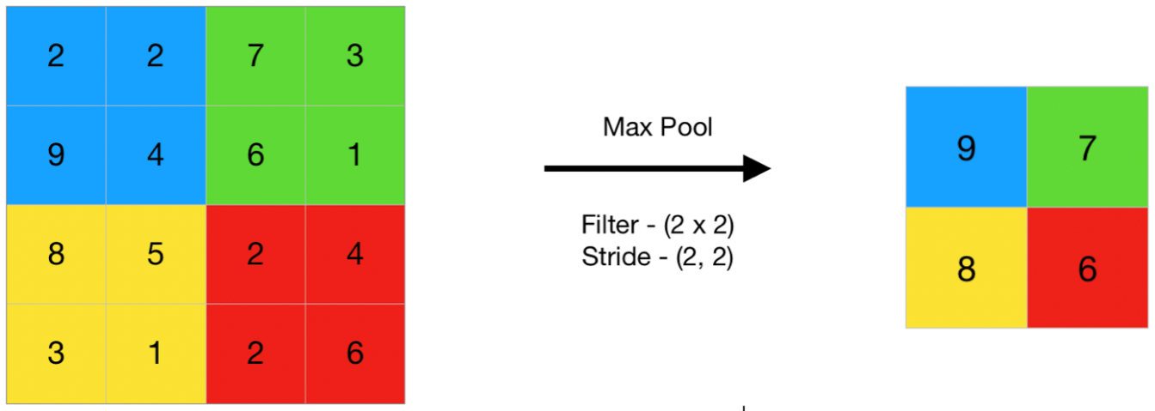

**Figure 6 MaxPool in CNN model**

**5.2.3 Batch Normalization:**

Batch normalization, it is a process to make neural networks faster and more stable through adding extra layers in a deep neural network. The new layer performs the standardizing and normalizing operations on the input of a layer coming from a previous layer.

Batch normalization takes place in following steps:

* Normalization of the Input

Normalization is the process of transforming the data to have a mean zero and standard deviation one. In this step we have our batch input from layer h, first, we need to calculate the mean of this hidden activation.

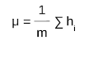

Here, m is the number of neurons at layer h.Once we have meant at our end, the next step is to calculate the standard deviation of the hidden activations.

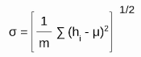

Further, as we have the mean and the standard deviation ready. We will normalize the hidden activations using these values. For this, we will subtract the mean from each input and divide the whole value with the sum of standard deviation and the smoothing term (*ε*).

* Rescaling of Offsetting

In the final operation, the re-scaling and offsetting of the input take place. Here two components of the BN algorithm come into the picture, γ(gamma) and β (beta). These parameters are used for re-scaling (γ) and shifting(β) of the vector containing values from the previous operations.

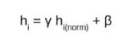

These two are learnable parameters, during the training neural network ensures the optimal values of γ and β are used. That will enable the accurate normalization of each batch.

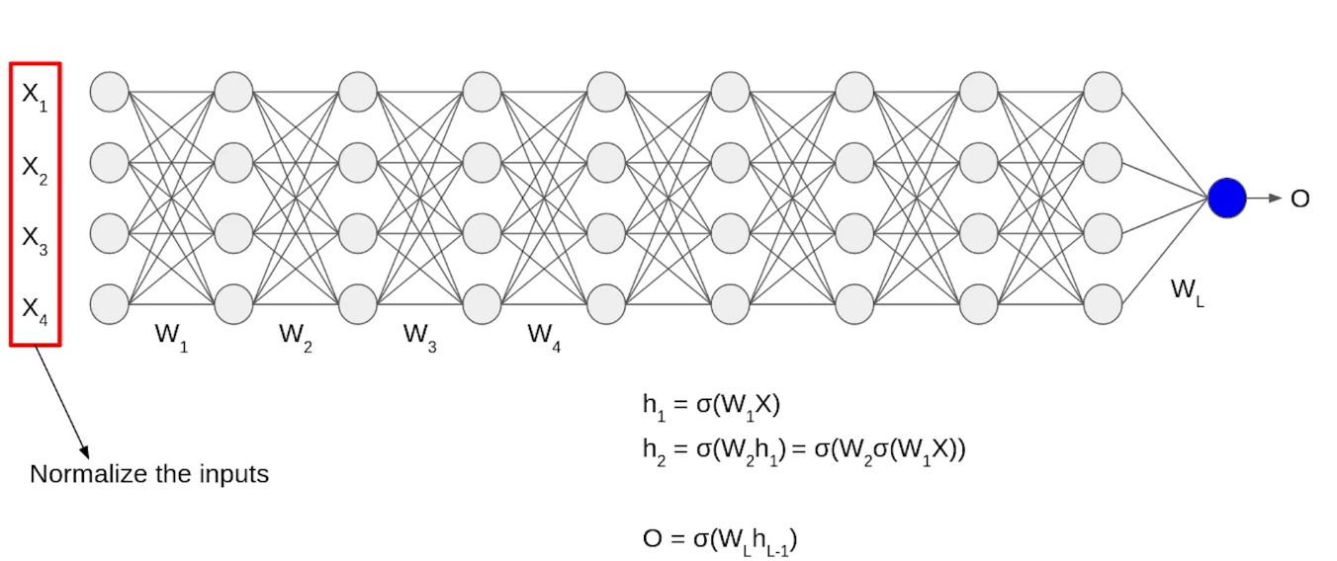

**Figure 7 Batch Normalization in CNN model**

**5.2.4 Dense Layer:**

It is a fully connected layer. Each node in this layer is connected to the previous layer i.e densely connected. This layer is used at the final stage of CNN to perform classification

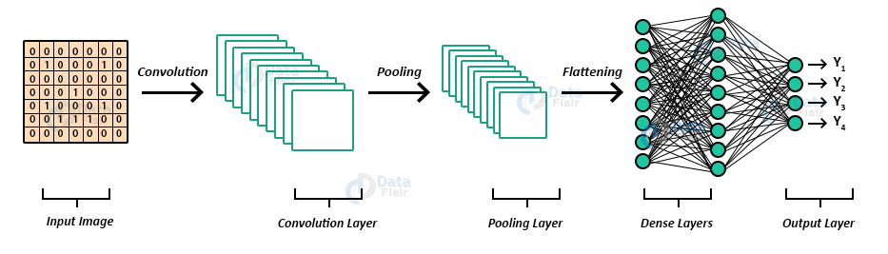

**Figure 8 Dense layer in CNN model**

**Chapter 6: Results**

**6.1 Model Output:**

These images are further passed through the training model, using this images the model is trained and after completing the training the model the testing and validation accuracy is measured.

The learning rate in the model is set as 0.0001 and the decay steps and decay rate is set at 10000 and 0.96 respectively.The amount that the weights are updated during training is referred to as the step size or the “learning rate”.

The model is runned for 20 epochs cycle after completing the 20 epocs the model training accuracy is measured at 98.02% and model validation accuracy is given as 99.5%, model training loss and model validation loss obtained is 2.3% and 1.2% respectively.

The black and purple lines depict the training accuracy and validation accuracy which should be higher than the training loss and validation loss which are depicted by the blue and red line in the graph shown below. Validation accuracy is the accuracy of the trained model to predict the validation dataset correctly; higher validation accuracy means that trained model is performing in the best possible way and it will predict the accurately in real world.

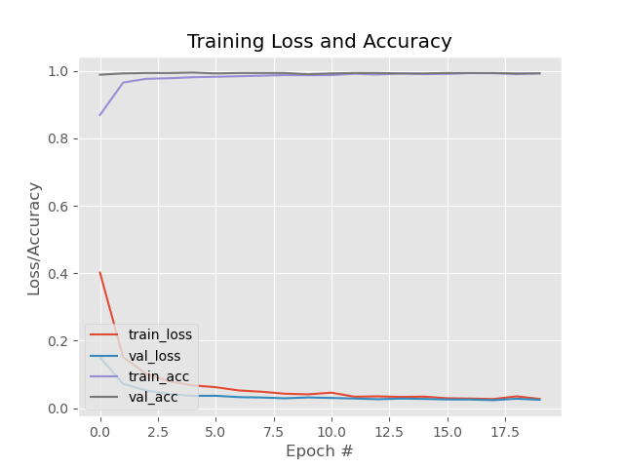

**Figure 9 Training Loss and Accuracy**

**6.2 Prediction Output:**

**6.2.1 Without Mask:**

After the model is trained with the help of system camera we will classify the image captured as mask and unmask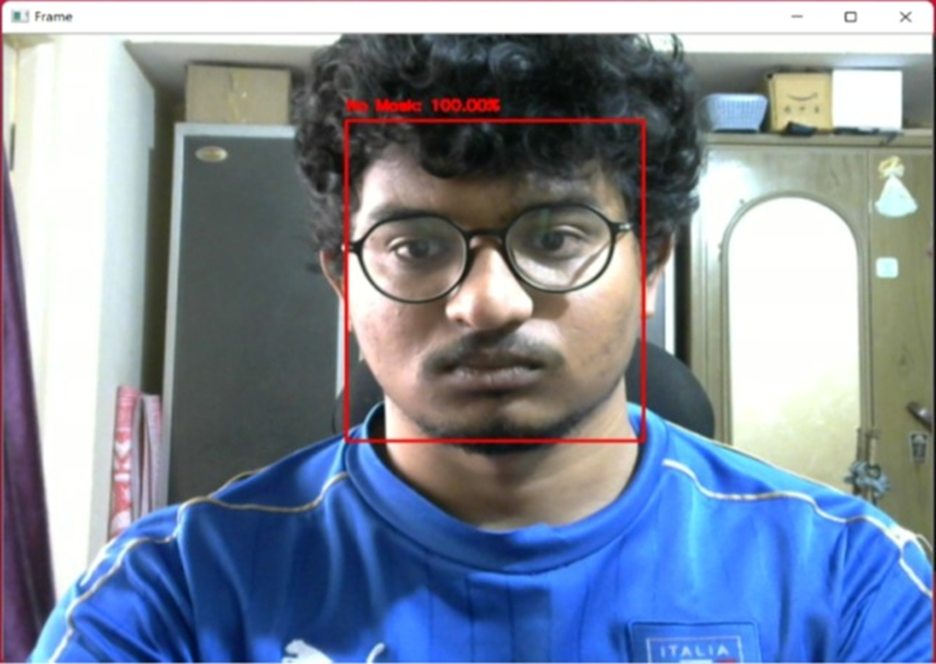

**Figure 10 Without Mask (Single Person)**

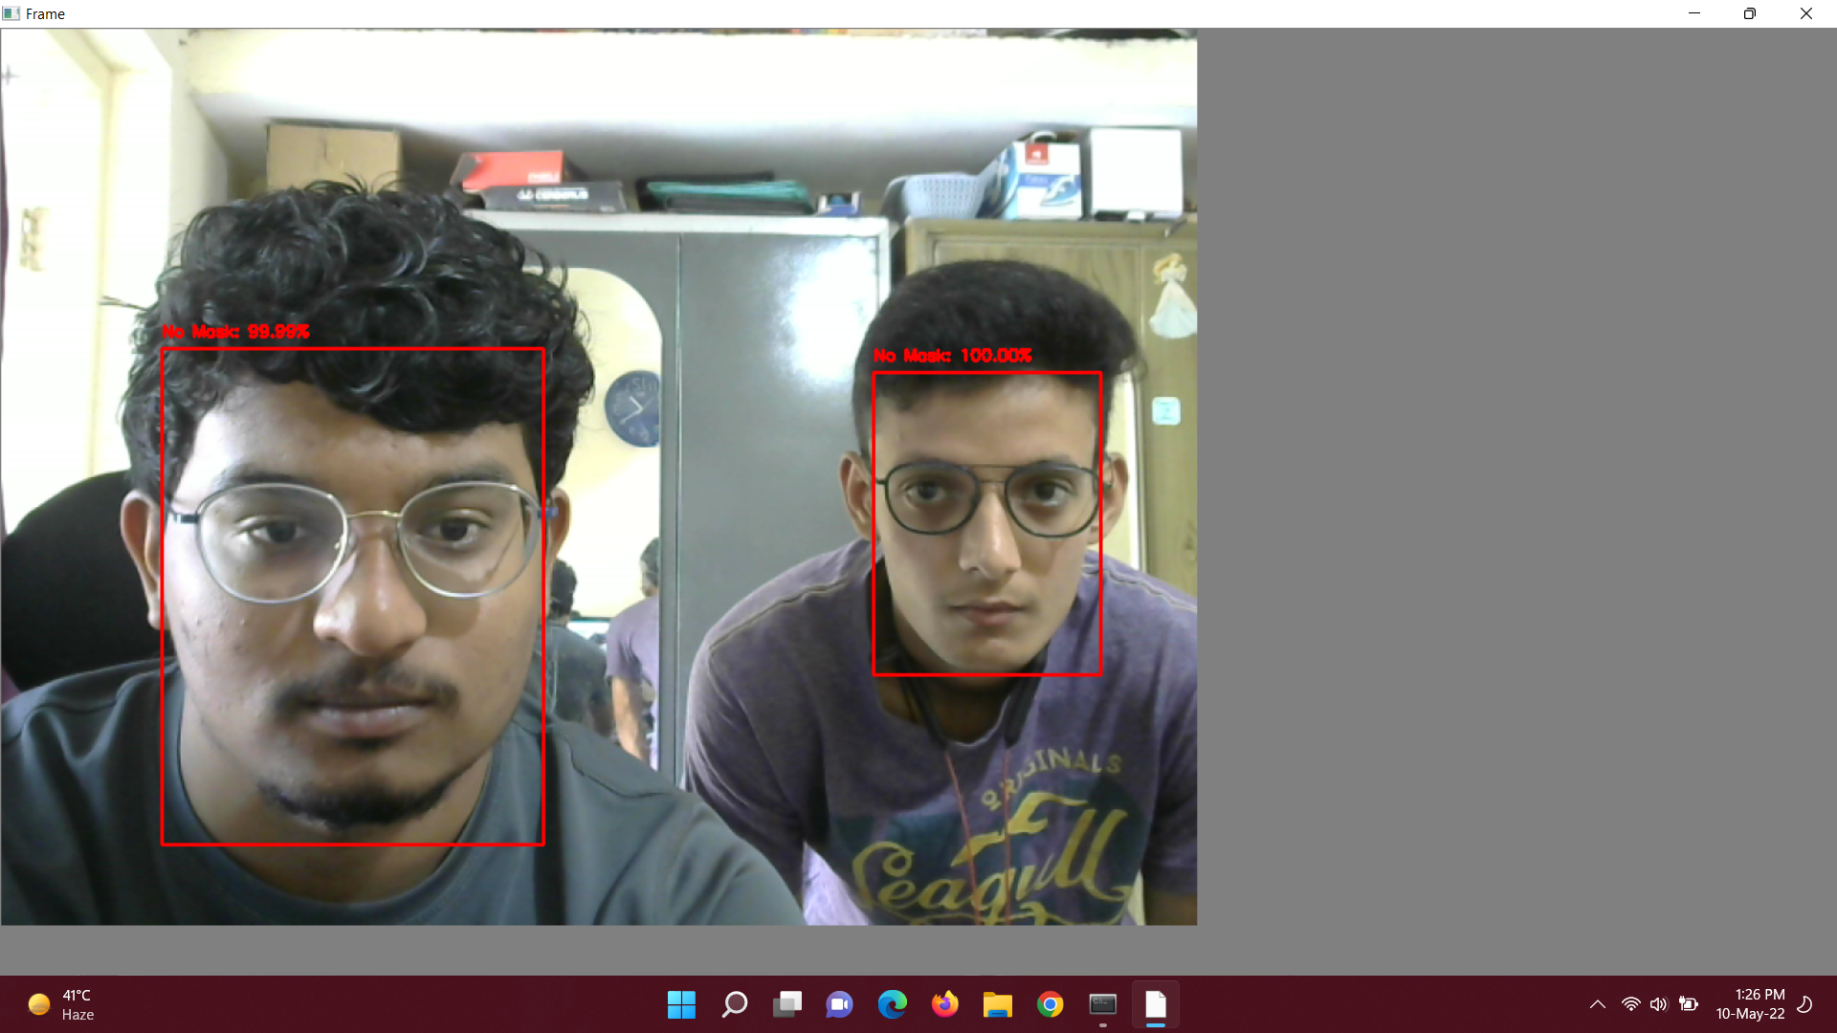

**Figure 11 Without Mask (Multiple Person)**

**6.2.2 With Mask:**

When a person Identifies the person not wearing Mask And those details not in the database it tries Match faces in the database. A bounding box drawn over the face of the person describes weather the person is wearing a mask

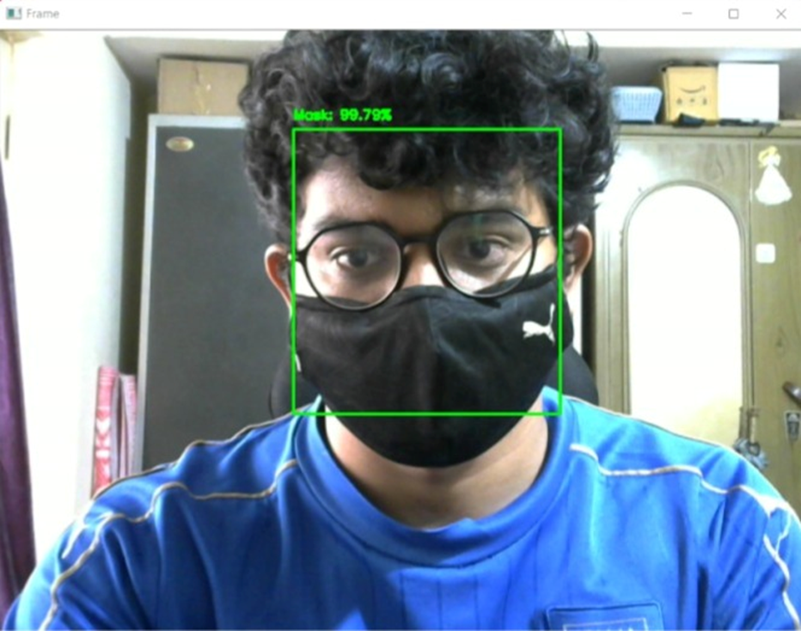

**Figure 12 With Mask (Single Person)**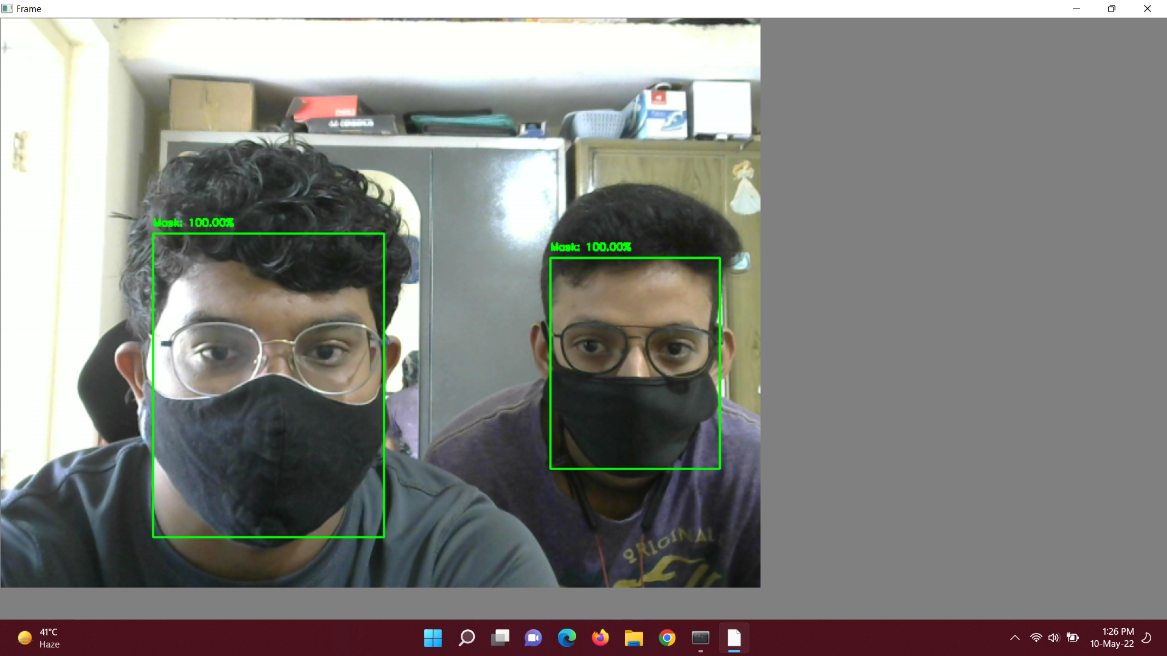

**Figure 13 With Mask (Multiple Person)**

**6.2.3 One Person with Mask One without Mask:**

**Figure 14 One Person with Mask One without Mask**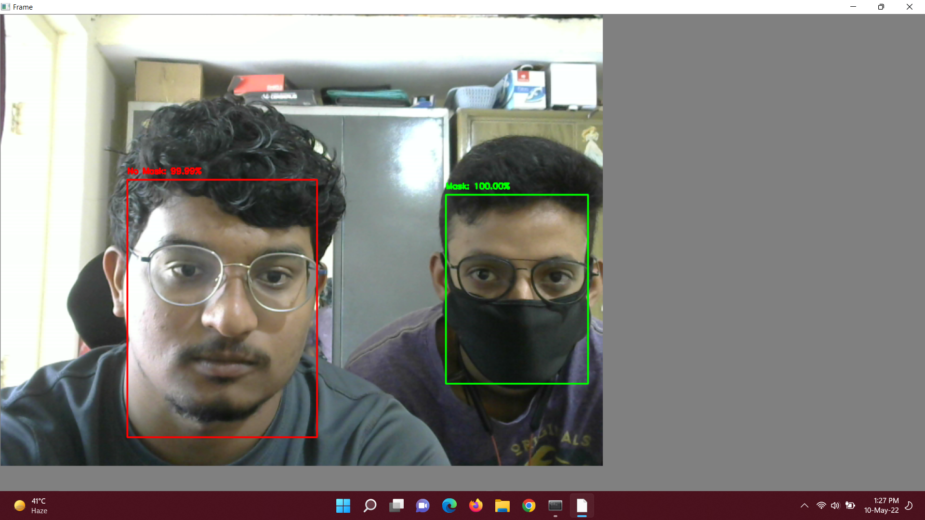

**Chapter 7: Conclusion and Future Scope**

**7.1 Scope:**

The proposed system can be enhanced to detect multiple faces available on the screen using multi colour channels.

**7.2 Conclusion:**

With the increasing number of COVID cases all over the world, a system to replace humans to check masks on the faces of people is greatly needed. This system satisfies that need. This system can be employed in public places like railway stations and malls. It will be of great help in companies and huge establishments where there will be a lot of workers. This system will be of great help because it is easy to evaluate whether the person is wearing a mask or if he is not wearing a mask.

**Chapter 8: Literature cited**

[1] Covid-19 Face Mask Detection Using TensorFlow, Keras and OpenCV.Arjya Das,Mohammad Wasif Ansari,Rohini Basak.2020.

[2] An Approach to Face Detection and Recognition.Divya Meena,Ravi Sharan.2017

[3] Face Mask Detection Using OpenCV Harish Adusumalli, D Kalyani, R.Krishna.2021

[4] Advice on the use of masks in the context of COVID-19.WHO.2019

[5] Face Mask Detection using Transfer Learning of InceptionV3 Year of publication: 2020 Authors: G. Jignesh Chowdary, Narinder Singh Punn ,Sanjay Kumar Sonbhadra and Sonali Agarwal

**Chapter 9: Appendix**

1. **Research Papers Referred**

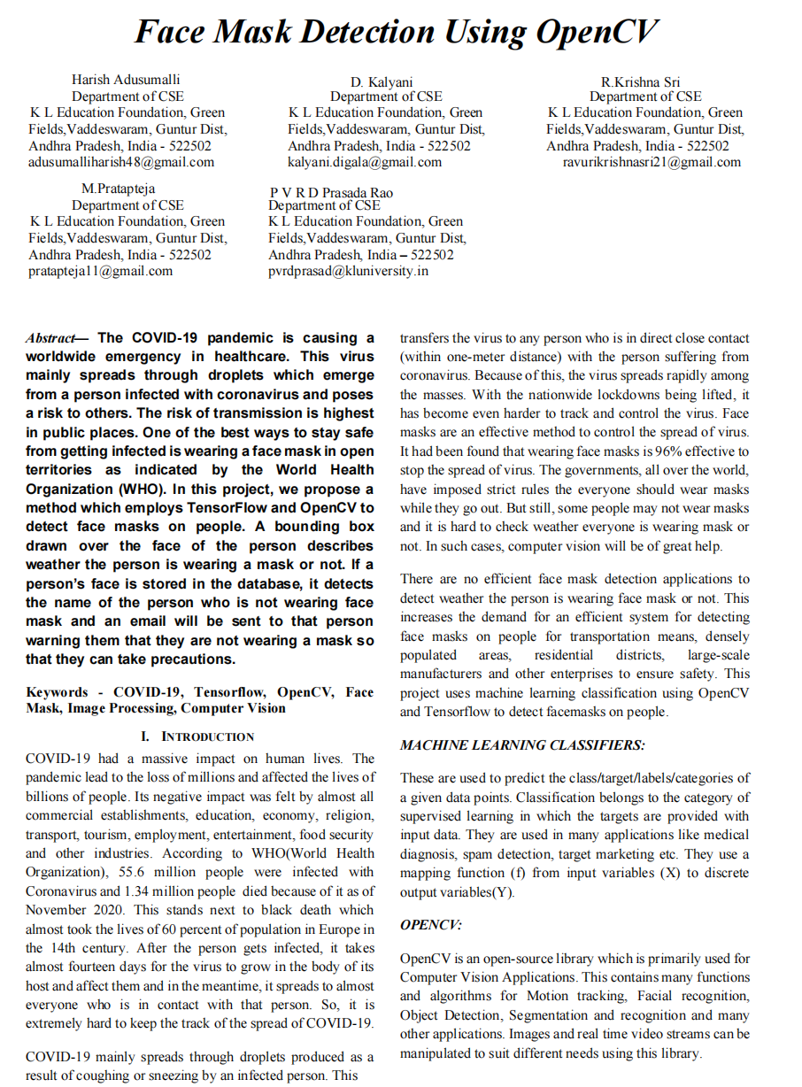

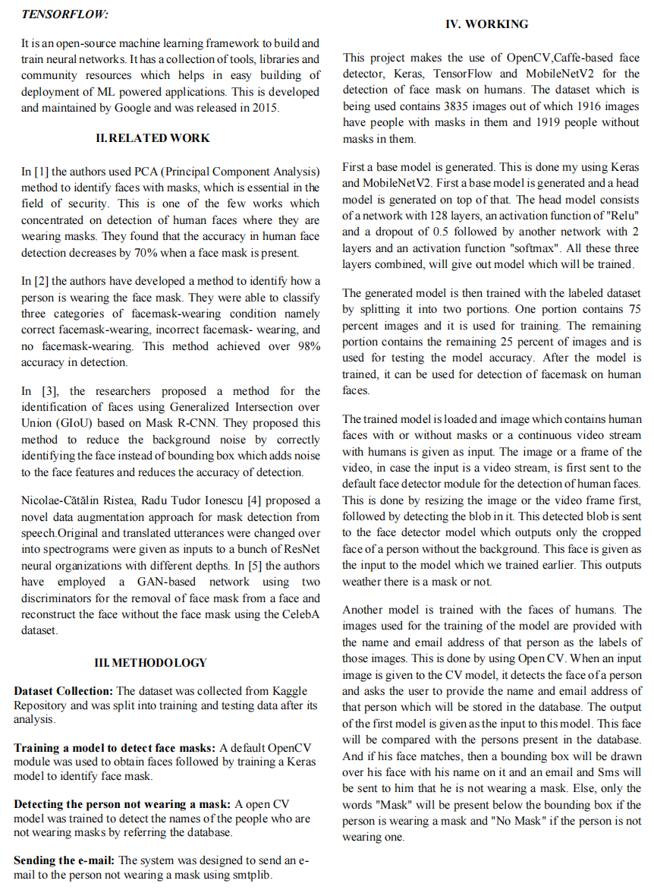

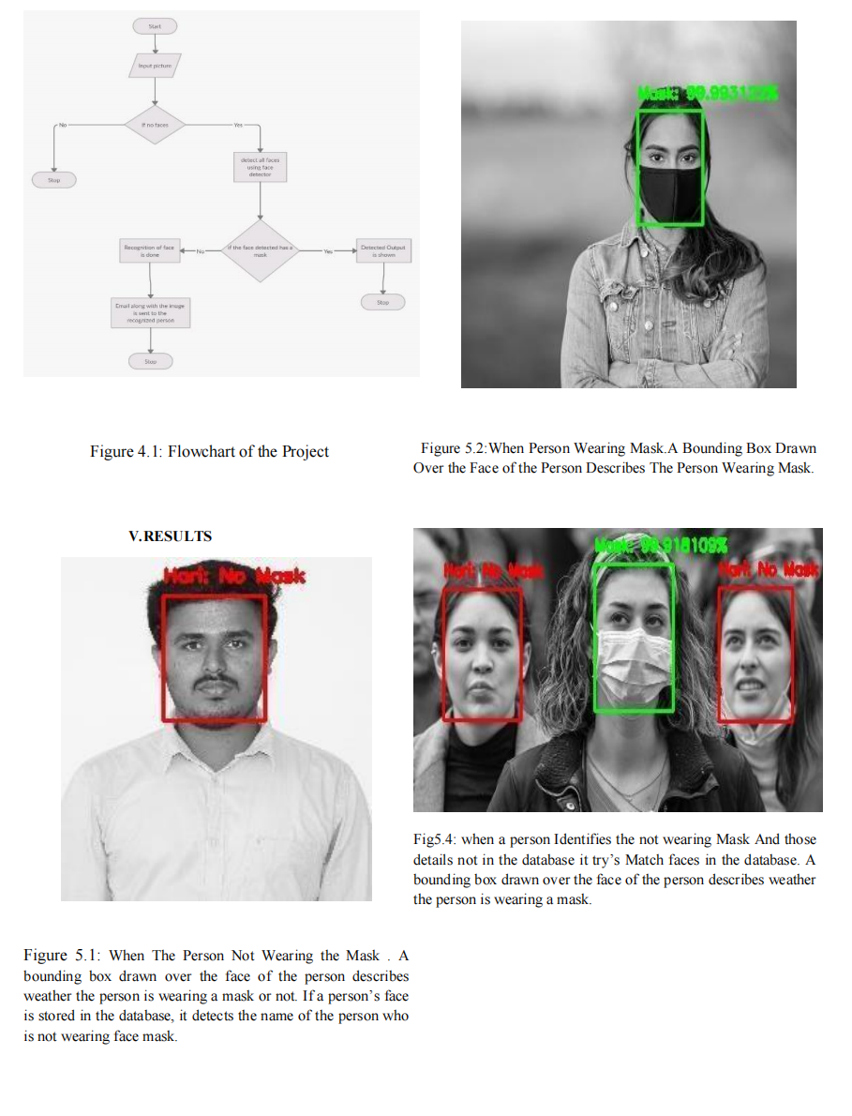

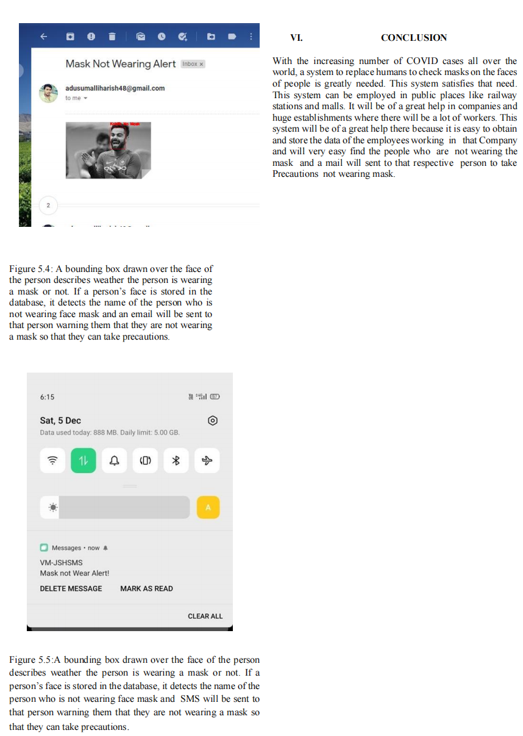

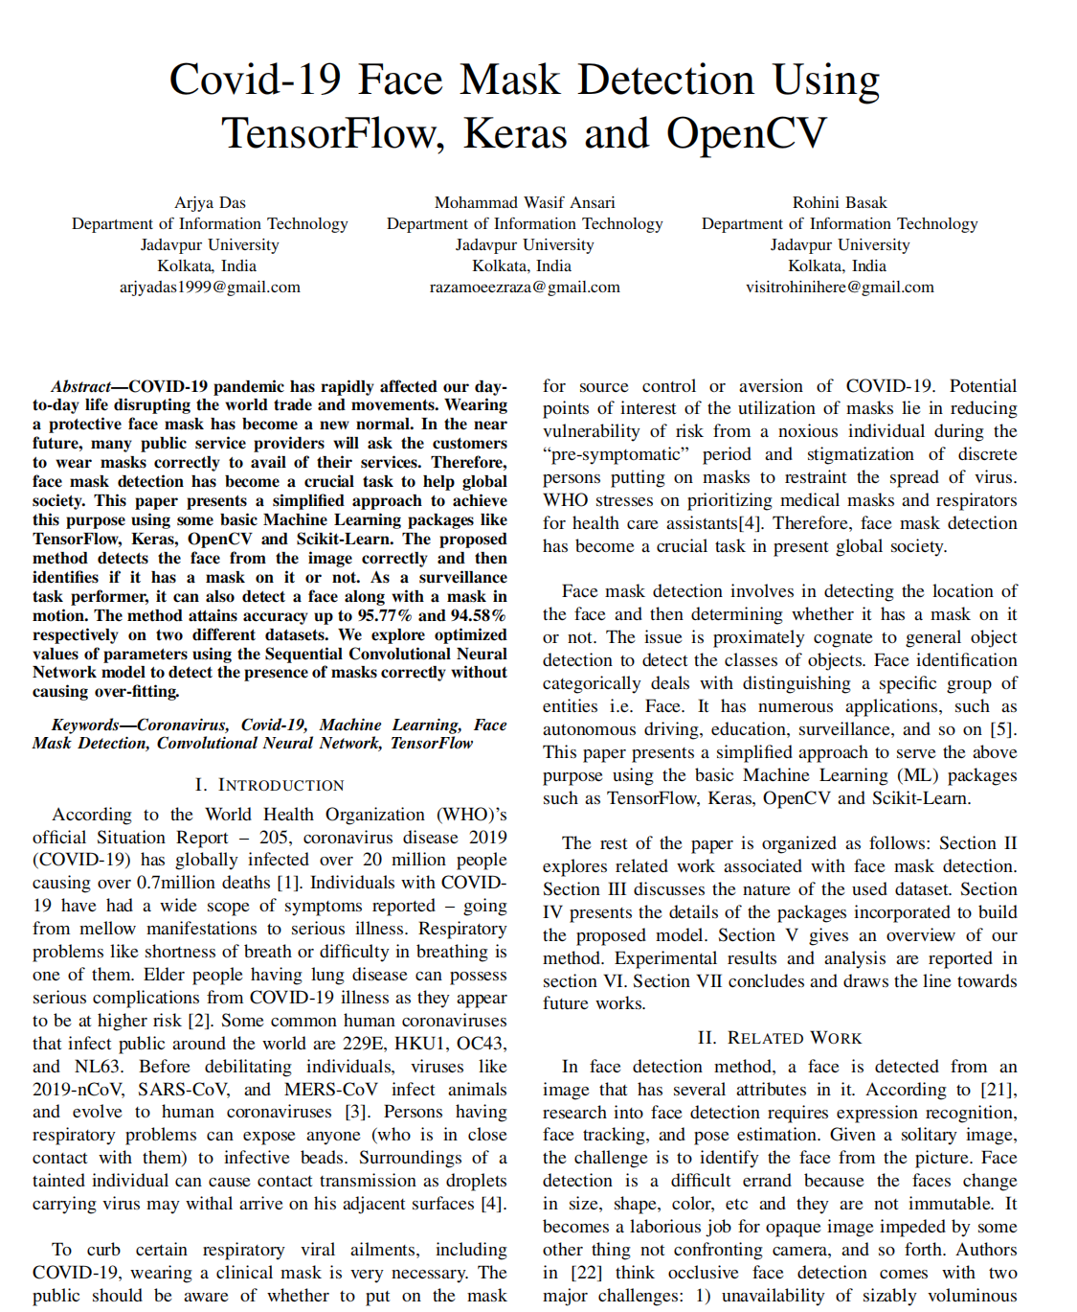

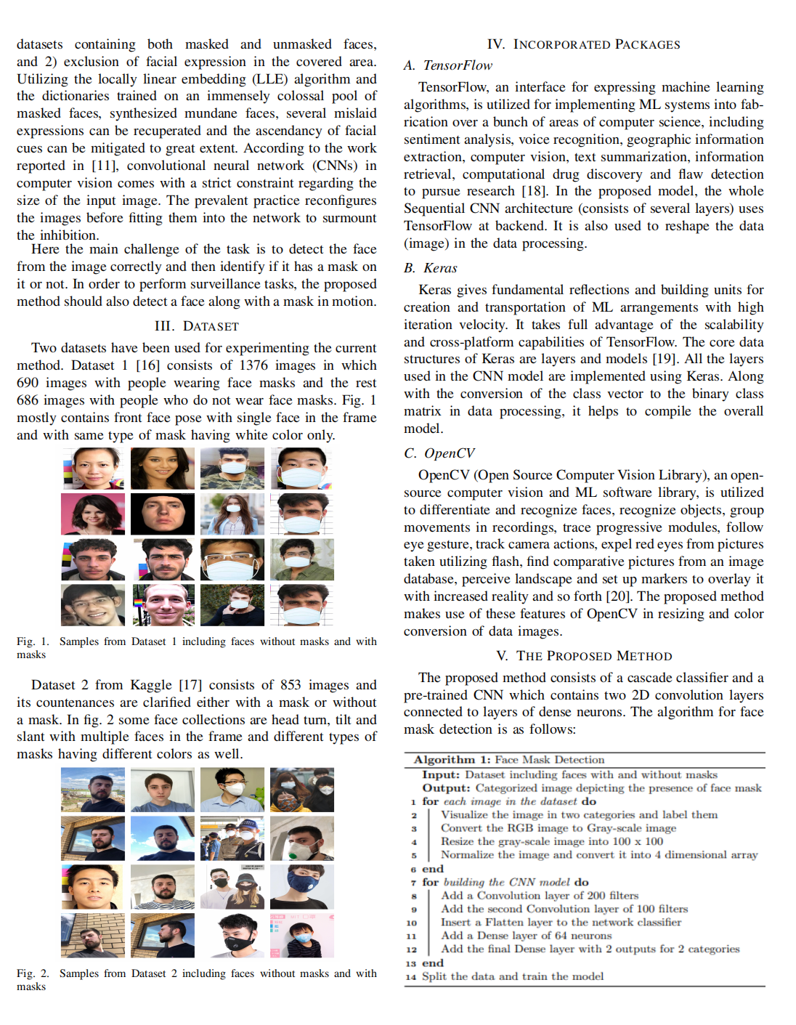

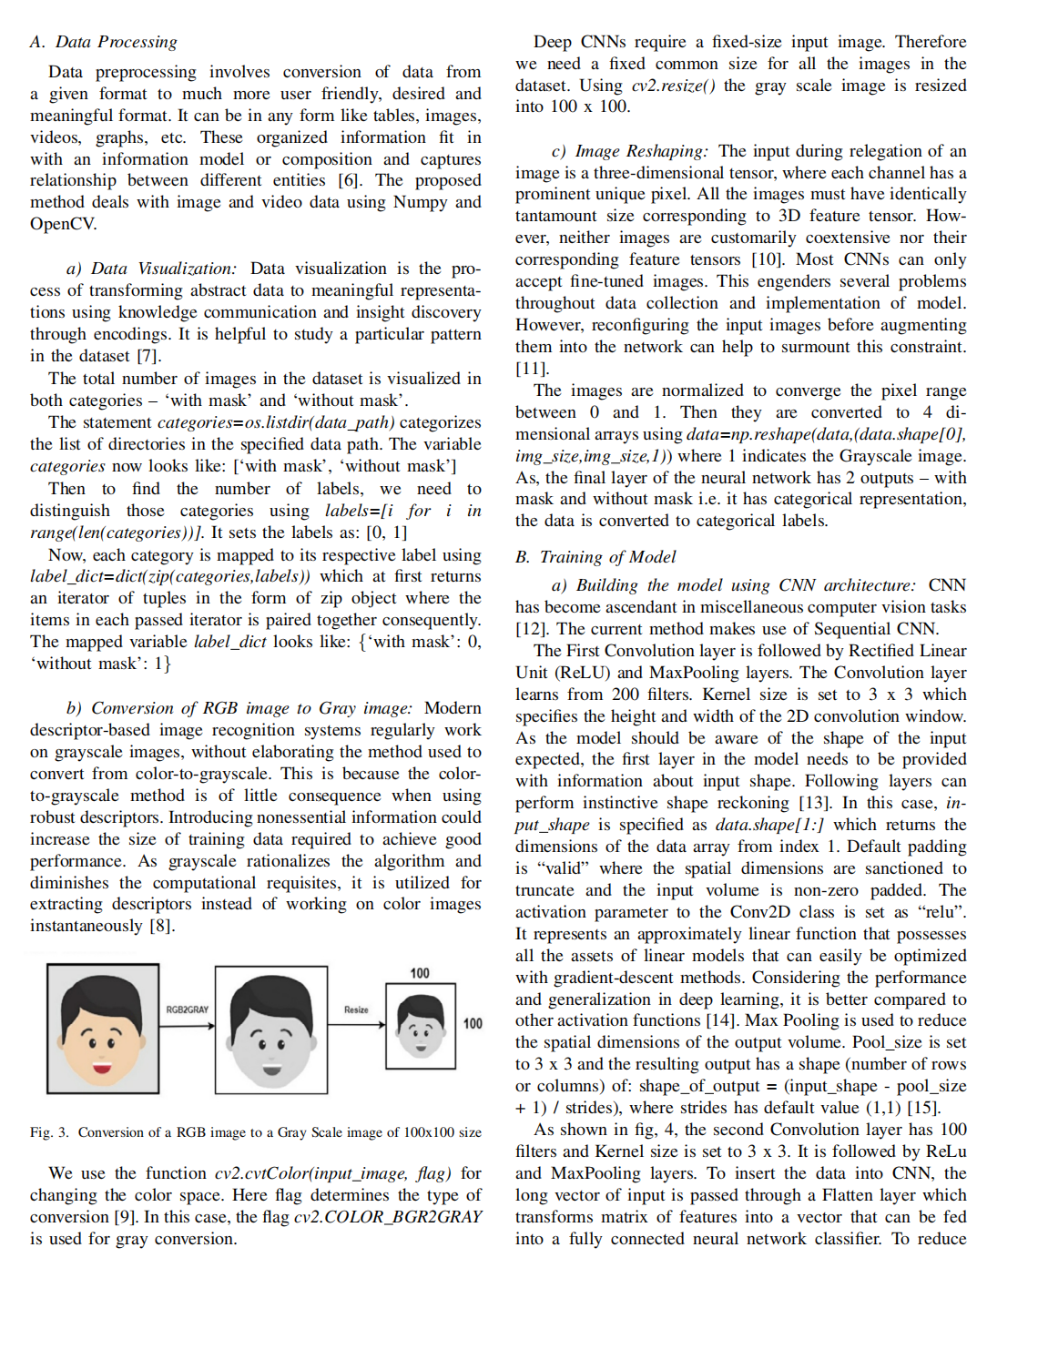

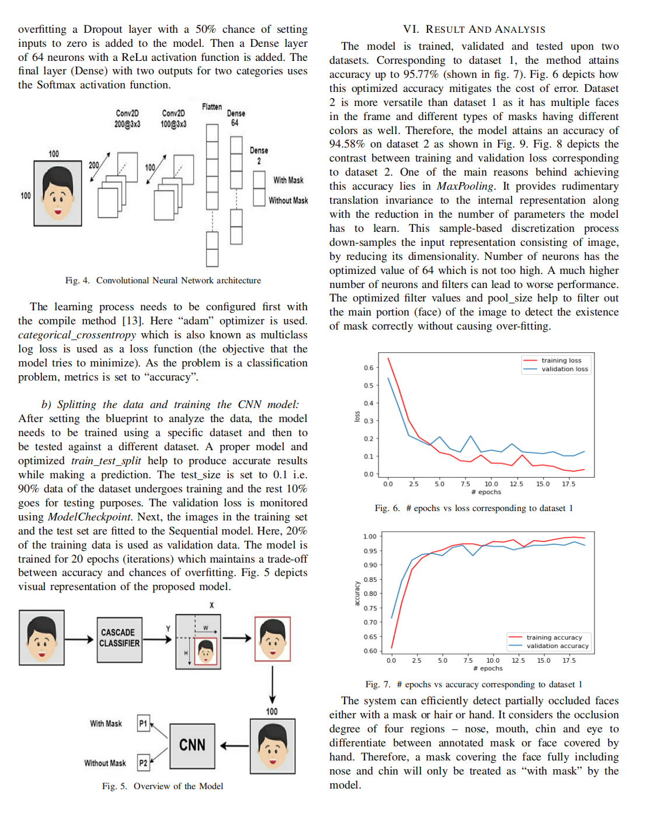

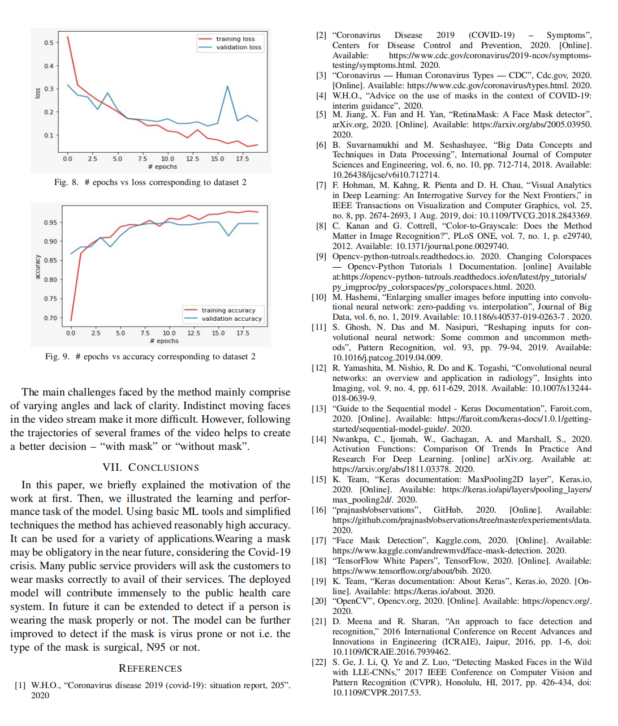

1. **CO and PO Mappings**

|  |  |  |  |  |  |  |  |  |  |  |  |  |  |  |  |  |  |  |  |  |
| --- | --- | --- | --- | --- | --- | --- | --- | --- | --- | --- | --- | --- | --- | --- | --- | --- | --- | --- | --- | --- |
|  |  |  | **Yeshwantrao Chavan College of Engineering** | | | | | | | | | | | | | | | | | |
|  |  |  | **Hingna Road, Wanadongri, NAGPUR - 441 110** | | | | | | | | | | | | | | | | | |
|  |  |  | **Department of Electronics & Telecommunication Engineering** | | | | | | | | | | | | | | | | | |
|  |  |  | **CO-PO MAPPING (Session 2021-22)** | | | | | | | | | | | | | | | | | |
|  |  |  |  |  |  |  |  |  |  |  |  |  |  |  |  |  |  |  |  |  |
|  |  |  |  | **P**  **O1** | **PO2** | **PO3** | **PO4** | **PO5** | **PO6** | **PO7** | **PO8** | **PO9** | **PO10** | **PO11** | **PO12** | **PSO1** | **PSO2** |  |  |  |
| VIII | ET2451 : Major Project | **1** | Design and analyze application based electronic systems. | **3** | **3** | **3** | **3** | **3** | **3** | **3** | **3** | **3** | **3** | **3** | **3** | **3** | **3** |  |  |  |
| **2** | Implement core / multidisciplinary / industry based electronics projects in cost effective manner. | **3** | **3** | **3** | **3** | **3** | **3** | **3** | **3** | **3** | **3** | **3** | **3** | **3** | **3** |  |  |  |
| **3** | Communicate technical details effectively | **3** |  |  |  | **3** |  | **3** | **3** | **3** | **3** | **3** | **3** | **3** | **3** |  |  |  |
|  |  |  |  |  |  |  |  |  |  |  |  |  |  |  |  |  |  |  |  |  |
|  |  |  |  |  |  |  |  |  |  |  |  |  |  |  |  |  |  |  |  |  |
|  |  |  |  |  |  |  |  |  |  |  |  |  |  |  |  |  |  |  |  |  |

1. **Project group information**

|  |  |  |  |
| --- | --- | --- | --- |
| Sr. No. | Name | Registration number | Email Id |
| 1. | Ritik Pusdekar | 18050070 | ritikpusdekar@gmail.com |
| 2. | Aakib Sayyad | 18050078 | aaqibsayyad@gmail.com |
| 3. | Mohit Zade | 18050013 | mohitzade29@gmail.com |
| 4. | Tejas Ubale | 18050008 | tejasubale18@gmail.com |
| 5. | Rohit Samarth | 18050080 | rohitsamarth.199@gmail.com |

**Chapter 10: Relevance of Project**

COVID-19 had a massive impact on human lives. The pandemic led to the loss of millions and affected the lives of billions of people. Its negative impact was felt by almost all commercial establishments, education, economy, religion, transport, tourism, employment, entertainment, food security and other industries. According to WHO(World Health Organization), 55.6 million people were infected with Coronavirus and 1.34 million people died because of it. After the person gets infected, it takes almost fourteen days for the virus to grow in the body of its host and affect them and in the meantime, it spreads to almost

everyone who is in contact with that person. So, it is extremely hard to keep track of the spread of COVID-19. COVID-19 mainly spreads through droplets produced as a result of coughing or sneezing by an infected person. This transfers the virus to any person who is in direct close contact (within one-meter distance) with the person suffering from coronavirus. Because of this, the virus spreads rapidly among

the masses. With the nationwide lockdowns being lifted, it has become even harder to track and control the virus.

Face masks are an effective method to control the spread of virus. It has been found that wearing face masks is 96% effective to stop the spread of virus. The governments, all over the world, have imposed strict rules that everyone should wear masks while they go out. But still, some people may not wear masks and it is hard to check whether everyone is wearing a mask or not. There are no efficient face mask detection applications to detect whether the person is wearing a face mask or not. This increases the demand for an efficient system for detecting face masks on people for transportation means, densely populated areas, residential districts, large-scale manufacturers and other enterprises to ensure safety. This project uses machine learning classification using OpenCV and Tensorflow to detect facemasks on people.

During this period it was important for companies and institutions to check if people are following the mandate and wearing masks. So the system we have made will help these companies and institutions in keeping track of people wearing masks and people not wearing masks. The project can be useful in two ways:

1. For companies to check if the customer availing their services is wearing a mask or not
2. For institutions to keep track of people who are not wearing a mask

By making sure that people are wearing masks while availing services or while walking around a crowded

place is one of the best ways to reduce transmission of Covid-19 virus. The project aims to help in the compulsion of wearing masks in dire conditions such as a pandemic or an epidemic right now or even in the future when another virus strikes us.